For immediate release:
CURATED BY LEANDAKATELOUISE

TORTOISE
Rose Davey / Gary Woodley
Claire Dorsett / Bruce McLean
Sarah Kate Wilson / Lisa Milroy

WW Gallery, London
12 February - 15 March 2013
Vernissage Wednesday 12th February 6-9pm
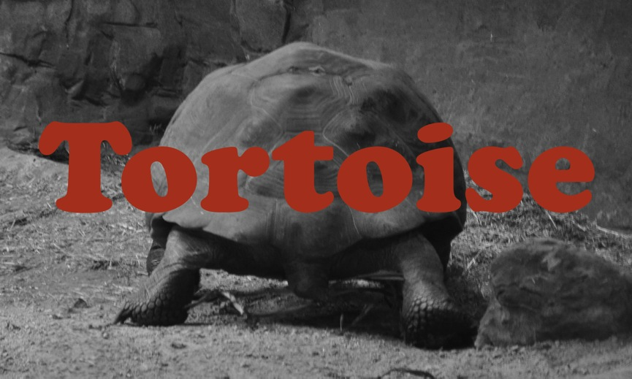

'We called him Tortoise because he taught us.'

TORTOISE takes its name from a line in Lewis Carroll’s novel Alice in Wonderland.
LeandaKateLouise have each invited an artist who once taught them to exhibit new works alongside their own, at artist run space WW Gallery.
The starting point for this show arose from a desire to exhibit with another artist whose work or influence we felt was important to our current practice. Artists could choose to show individual works or collaborate together on new work.
As TORTOISE progressed, we felt it was also important to acknowledge the role of art school, as this is where we all met. Art schools are complex places, where sometimes the best advice is to not make art. This is something you might choose to do when you leave?
From the experience of the institutions we have attended the art school is one of the last places left within education where a student’s curiosity alone is enough to warrant the exploration of any chosen topic. A student’s line of inquiry is not motivated by aiming to achieve the best exam results, or by attempting to win favour with the institution, or by trying to make a piece of work more commercially viable. Unexpected ideas are arrived at by having the space, time and support to follow one’s own curiosity, instead of interrogating it out of action by asking how, why and when before you’ve even started.

There is no educational outcome in a linear sense, but a wealth of knowledge and experience is accumulated through process. Art school teaches you how to question and edit your own ideas as part of a self-critical dialogue where often the most successful decisions are instinctive. One is only aware of the range of skills that art schools equips you with when you are able to create something out of nothing at anytime, anywhere. Obstacles are now viewed as a catalyst to discovering a more exciting solution rather than a barrier between A and B.

These lessons are learned with the support of tutors and through interaction with fellow students. Now outside of the context of the art school and into the environment of the gallery, TORTOISE sees the role of student and teacher dissolve into artist and artist. The viewer is left to decide if the former relationship between artists continues to define the present.

LeandaKateLouise have each selected only one artist to exhibit alongside but this is not to ignore the many others who have also inspired through their dedication and invaluable contribution to the teaching profession.

Biographies

Rose Davey (b. London 1984) graduated from The Slade School of Fine Art, London in 2010, (MFA Painting). Recent exhibitions include Significant Others: Part 2, 2013, Advanced Graphics London, Creekside Open Selected by Ceri Hand, 2013, APT Gallery, London, Assemble, 2012 Liquid Courage Galley, Nassau, Bahamas. Alongside her studio practice Davey is freelance curator and guest Art History lecturer at The Slade School of Fine Art.

Claire Dorsett (b. 1985, Ipswich, UK) graduated from The Slade School of Fine Art, London in 2010, (MFA Painting). Recent solo exhibitions include The Solo Project, 2013, St. Jakobshalle, Basel, Switzerland and You Do The Talking, 2012, George and Jørgen Gallery, London. She is currently a visiting lecturer at The University of Brighton.

Bruce McLean (b. Glasgow, Scotland) graduated from St. Martins School of Art in 1966. He has taught at The Slade School of Fine Art and The Rijkesakademie Van Beldende Kunsten, amongst others. Recent solo exhibitions include Time-Based Painting, 2012, Tanya Leighton, Berlin and The Shapes of Sculpture, 2012, Bernard Jacobsen Gallery, London. In 2014 he will present two new solo exhibitions of work; Bruce McLean, firstsite, Colchester, UK and Beyond The Pose, Leeds Art Gallery, Leeds and will be included in the group exhibition I Cheer A Deadman's Sweetheart, De La Warr Pavilion, Bexhill on Sea, UK.

Lisa Milroy (b. Vancouver, Canada) graduated from Goldsmiths College in 1982. Presently Head of Graduate Painting, Slade School of Fine Art, UCL, and Artist Trustee, Tate. Recent solo exhibitions include Party of One, 2013, Crate, Margate; Act One, Seen Too, 2012, Bloomsbury Theatre, London; Improvisations, 2011, Royal West of England Academy, Bristol; Shouting From A Rock, 2010, Pharos Centre for Contemporary Art, Nicosia, Cyprus. Her work will be included in the group exhibition I Cheer A Deadman's Sweetheart, De La Warr Pavilion, Bexhill on Sea in March 2014.

Sarah Kate Wilson (b. 1982 Grand Cayman, Cayman Islands) graduated from The Slade School of Fine Art, London in 2010, (MFA Painting). Selected exhibitions include: PART THREE: Oblique Exchange, 2013, APT Gallery, London, UK, Uncle Vern’s Dog, Gallery North, Newcastle, 2013; Jerwood Drawing Prize 2012, shortlisted (UK touring). She co-curated and participated in the UK touring exhibition Malerei; Painting as Object, 2012. She is currently a practice based PhD. candidate at Leeds University (AHRC).

Gary Woodley (b. London, UK) graduated from Chelsea School of Art in 1978. He has taught at The Slade School of Fine Art since 1988. Recent solo exhibitions include Impingement No. 58, ‘Loxodrome’, 2012, Cairn Gallery, Pittenweem, Scotland, and specially commissioned works for nothing is forever, 2010, South London Gallery, London, Kettles Yard at Tate Britain, 2009, Tate Britain, London, Project Francise, 2007, R C de Ruimte, Ijmuiden and Beverwijk, Netherlands.

info@leandakatelouise.com
www.LeandaKateLouise.com

Supported by

Carroll, L. (1865). Alice’s Adventures in Wonderland. London: Macmillan, p.121.

