For immediate release:
SOLO award winner 2013

LAURA FITZGERALD: WORK BASED ANXIETIES

WW Gallery, London
8 January - 1 February 2014
Vernissage Tuesday 7th January 6-9pm

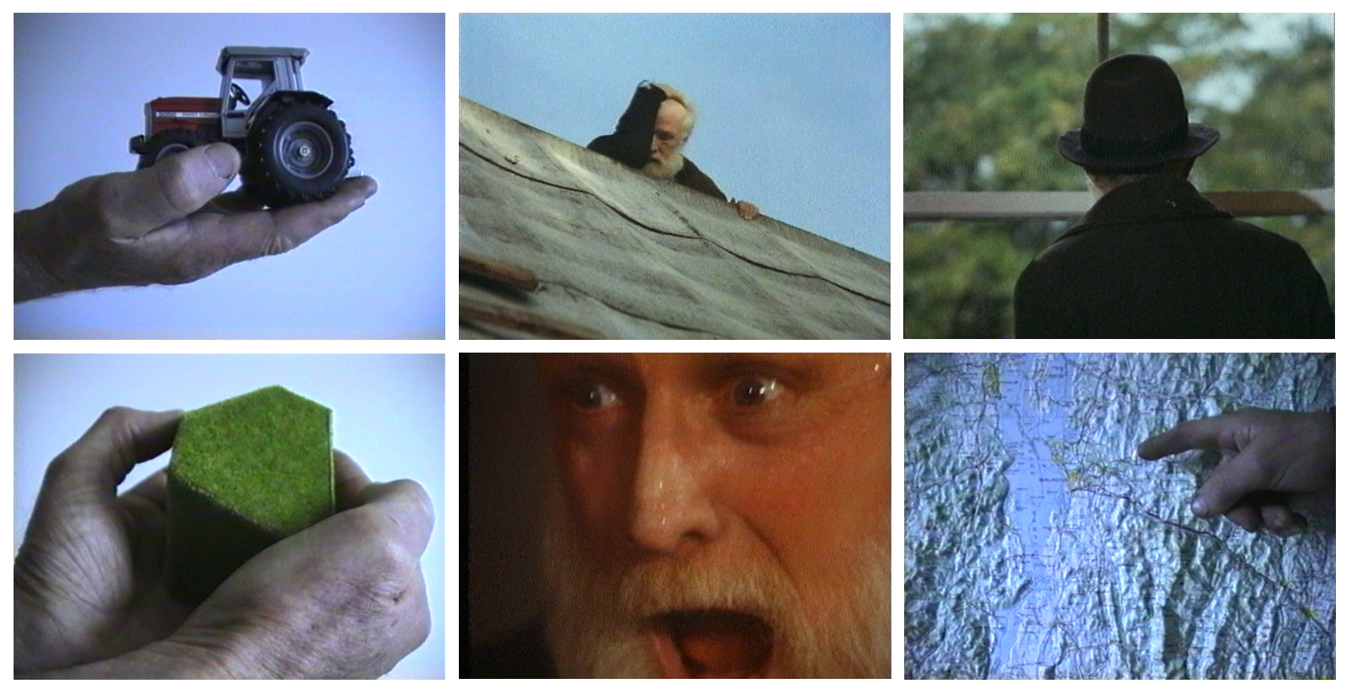

LAURA FITZGERALD is winner of the WW SOLO Award 2013, selected by Alison Wilding, Ceri Hand, Charlotte Mullins and Gill Saunders. WW Gallery is pleased to present Fitzgerald’s solo show WORK BASED ANXIETIES.

Laura Fitzgerald’s narrative video works weave autobiographical and fictional elements to navigate her role as an artist, with results that range from the romanticized to the absurd. In WORK BASED ANXIETIES, the artist, the statement and the work are in a state of crisis. Each is on a separate trajectory and as a result, an anxiety is pervading throughout mental and physical states of being. Returning to the idea of examining what an artwork is, this new work looks to some of the structures at play within the occupation of being an artist.

ABOUT THE ARTIST
Laura Fitzgerald is an Irish artist based in London and Inch, she graduated from the Royal College of Art in 2013. More information: www.laurafitzgeraldfrominch.com

ABOUT THE WW SOLO AWARD 2013
The WW SOLO Award 2013 was the second in an ongoing annual award that seeks to support up and coming artists working at all stages of their career. The prize includes £1000 prize money, a group show and three months mentoring culminating in a solo exhibition. This year almost 1800 entries by 600 artists were received, 26 artists were long-listed for a group exhibition at the gallery in August from which 6 artists were shortlisted before Fitzgerald was selected as the winner. More information about the SOLO Award: http://www.wilsonwilliamsgallery.com/solo.htm

Image: Laura Fitzgerald, Work Based Anxieties, video stills, 2013

