For immediate release:
DIRECTORS’ CUT:
CHIARA WILLIAMS / BOA SWINDLER
WW Gallery, London
30 October - 30 November 2013
Vernissage Tuesday 29th October 6 - 9pm

DIRECTORS’ CUT is the first pairing of WW’s directors Chiara Williams and Debra Wilson, aka Boa Swindler.
Their most personal exhibition to date, it brings together two very different women – who in their lives and in their practices are like chalk & cheese - and celebrates the common ground they share.

Drawing on an ever-increasing deluge of contemporary visual images of women (from fashion magazines, music videos, TV, billboards, blogs and social media), Williams and Swindler both look at the impact these representations have upon women.
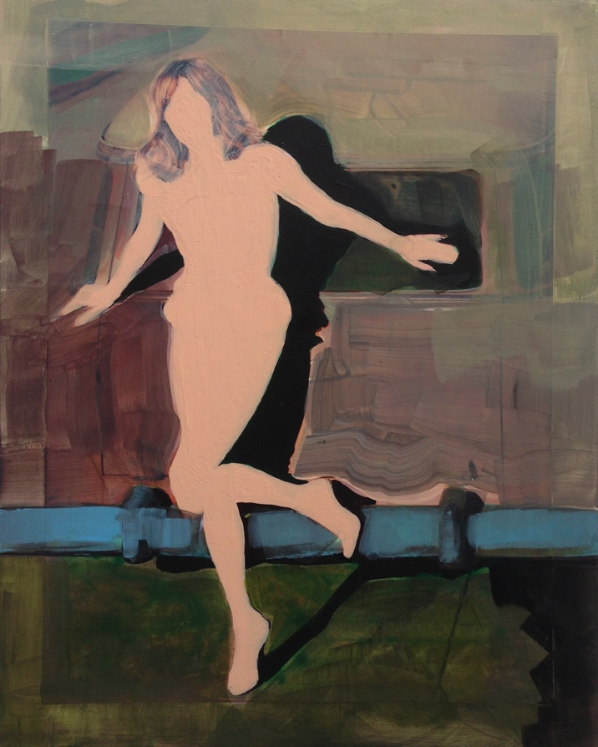
Females of all ages still appear to be obsessed with getting their body ‘right’, measuring themselves against impossible media templates, even when it is glaringly obvious that digital manipulation has intervened to create the apparent perfection. It seems that unless a woman has a body she feels good about, nothing much else in her life feels right either. She allows her body, rather than her mind, to define her and dictate the way her life is lived.

Williams’s work investigates the homogenisation of female beauty. In her new series of paintings, created from the seductive, aspirational, fantastical and stylised language of pictorial aesthetics found in publications such as Vogue, women are depicted with eerily featureless faces, airbrushed or obliterated beyond recognition.

Swindler’s work arises out of issues surrounding power and persuasion. Her new series of assemblages, prints and mixed media works is inspired by Susie Orbach’s Fat is A Feminist Issue and explores the bullying, intimidation and marginalisation of big women in society. Swindler accuses us all of being colluders in this culture of demeaning women for their size, which reinforces female insecurities and hinders equality. But there is also a good dose of wit at play here, as well as a nod to Josef Beuys and the protective and healing properties of fat.

Although not an inherently revolutionary show, DIRECTORS’ CUT makes a point about things that still need to be said, delivered with WW’s characteristic irreverence, humour and what has been described as the pair’s signature mix of glamour and edge.

ABOUT THE ARTISTS
For more information, about the artists:
http://www.chiarawilliams.com
http://www.wilsonwilliamsgallery.com/boa.htm
Image: Chiara Williams, Brushed #3, acrylic and oil on paper and board, 31.5 x 25cm, 2013

