For immediate release:
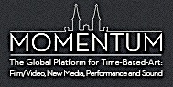
MOMENTUM presents
About Face: Jarik Jongman | Mariana Hahn| Sarah Lüdemann
at WW Gallery, London
Friday 11th – Sunday 20th October 2013
Preview: Thursday 10th October, 6 - 9pm
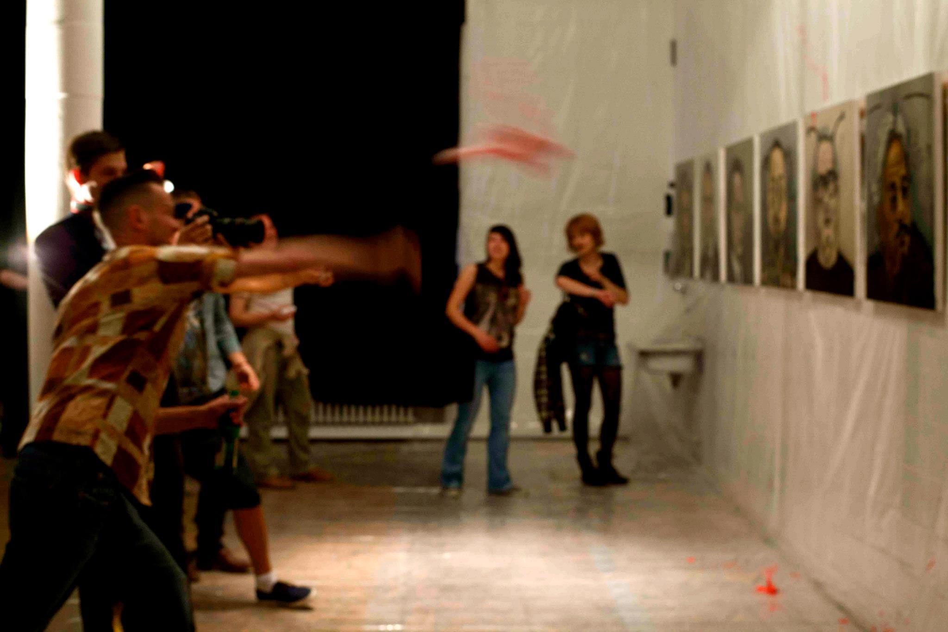

About Face | a command, a commentary on our tumultuous times and a reaction to the cult of beauty perpetuated throughout contemporary culture.

WW Gallery is excited to host About Face, a group exhibition, curated and produced by Rachel Rits-Volloch and Cassandra Bird directors of Momentum (Berlin). First exhibited in Berlin in 2012, About Face dynamically addresses this century’s great crises and questions its icons in a collaboration of painting, performance, video and poetry. This modern turmoil is given a face for destruction and then turned inward (volte-face), to self-destruction, challenging perceptions and engaging the visitor in the symbiosis of the creative and decreative.

The three artists in this exhibition converge upon these issues in very different ways and mediums. Jarik Jongman introduces performance into his interactive painting series (de)facing revolt (2012). Ten portraits of iconic members of the art world are faced and defaced by artist and audience, leaving mutilated images that recall ousted dictators. Mariana Hahn’s performance I Sweat You (2012) reflects states of being and becoming. Performing draped in plastic, a defunct art ‘object’, her poetry sticks in the mind and gets under the skin. Sarah Lüdemann’s film Schnitzelporno (2012) looks at body and identity; its dissemination and (re)presentation. A self-portrait that lies upon to interpretation, Lüdemann explores psychological states and social roles for the perceived self.

Showing during 2013’s Frieze week, About Face demonstrates an alternative to consumerist, established art world in London, and allows the visitor to confront its dictators, be they collectors or creators.

For more information, about the exhibition and artists, there is an online catalogue: http://momentumworldwide.org/wp-content/uploads/2012/03/catalogue_Spreedruck.pdf

ABOUT MOMENTUM

MOMENTUM is a global platform for time-based art, with a mission to promote the work of and enable exchange between exceptional international artists, galleries and institutions while continuously reassessing the nature and relevance of time-based art. MOMENTUM is a non-profit institution which collaborates with both commercial and non-commercial galleries, private collections and art initiatives. For further information about MOMENTUM and directors Rachel Rits-Volloch and Cassandra Bird please visit their website: http://momentumworldwide.org/about-us/.

